


Forensic Clinical Resources
Forensic Clinical Resources are grouped by UST, NGRI, SVP, and Universal. Each item is tagged as one of three types:

✓ Templates: Orders, letters, petitions, and clinical reports are editable starting points for filling in case-specific information.
✓ Procedures: Workflow guides for processes such as conditional release packet review and medication petitions are editable and reflect current IDHS practice for local adaptation.
✓ Illustrative Items: IDHS reports are for reference and are not editable. The approved versions live in the IDHS document library on the internal intranet and are accessible only to authorized clinical staff.

Version Log
VERSION DATE | SECTION(S) REVISED | REVISION DESCRIPTION
2026-07-17 | N/A | New Document

Table of Contents
The right-hand tag marks each resource as a Template (editable, fill-in-the-blank), Procedures (workflow guide), or Illustrative (read-only reference; approved version on DBHR intranet).

UST — Universal
- UST Outpatient Workflow Overview | Procedures
- Unfit to Stand Trial –– A Plain Language Guide | Procedures

UST — Period 1: Leading up to UST Finding
There are no specific clinical resources for this period.

UST — Period 2: Standard (Initial) Fitness Restoration
- Inpatient Admission Letter | Template
- 30-Day Fitness to Stand Trial Admission Report | Illustrative Example
- 30-Day Outpatient Narrative & Progress Report | Template
- 90-Day Fitness to Stand Trial Progress Report | Illustrative Example
- 90-Day Outpatient Narrative & Progress Report | Template
- Statewide Immediate Transport Letter & Order | Template

UST — Period 3: Extended Treatment (NNG)
There are no specific clinical resources for this period. 90-Day Fitness Progress Report is used.

UST — Period 4: Post-Extended Treatment (g)(2)
There are no specific clinical resources for this period. 90-Day Fitness Progress Report is used.

NGRI — Universal
- Not Guilty by Reason of Insanity –– A Plain Language Guide | Procedures
- Recipient-Initiated Petition Packet | Procedure & Templates

NGRI — Pathway 1: Absolute Discharge
There are no specific clinical resources for this pathway.

NGRI — Pathway 2: Conditional Release
- Conditional Release Overview for Community Providers | Procedures
- Outpatient Treatment Cover Letter & Progress Report | Template

NGRI — Pathway 3: Secure Inpatient Treatment
- 30-Day Inpatient Evaluation | Illustrative Example
- 90-Day Progress and Treatment Plan | Illustrative Example
- Recommendation for Conditional Release | Template

UST Outpatient Workflow Overview | Procedures

Purpose and Scope
These procedures describe the workflow that begins when IDHS receives a court order remanding a defendant for outpatient fitness restoration, and continues through the 30-day evaluation, ongoing treatment, 90-day progress reporting, and any escalation to higher levels of care. They apply to clinical staff at outpatient restoration providers under contract with DBHR, and to the DBHR Forensic Outpatient Manager.
These procedures do not cover the substantive content of fitness restoration treatment (fitness education resources, restoration interventions). For that, contact the Forensic Outpatient Manager to request training materials for clinicians.

Statutory Framework Overview
Primary statute: 725 ILCS 5/104—Fitness to Stand Trial, To Plead or To Be Sentenced.
- A defendant is presumed fit and is considered unfit only if mental or physical condition prevents understanding the nature and purpose of the proceedings or assisting in defense 725 ILCS 5/104-10.
- The Initial Period of Treatment is never longer than one year from the date of the original finding of unfitness 725 ILCS 5/104-23(b).
- For a defendant charged with a felony, the period is one year. For a misdemeanor, the period is no longer than the sentence if convicted of the most serious offense.
- The 30-day report is governed by 725 ILCS 5/104-17(e).
Reference the Forensic Handbook or the statue directly for addition information on the statutory requirements for those delivering fitness restoration must follow.

Contacts and Roles
Forensic Outpatient Manager (FOM)
The FOM is the DBHR Bureau of Forensic & Justice Services point of contact for outpatient Unfit to Stand Trail (UST) referrals. The FOM receives the referral, identifies the appropriate treatment agency, forwards the court order and supporting materials, and provides ongoing consultation to the clinical team.
- Tima Smith, PsyD, PSA, Forensic Outpatient Manager (FOM)
- Email: Tima.Smith@illinois.gov
- Phone: (312) 636-7302
Treatment Agency Roles
Once a referral is accepted, the treatment agency is responsible for:
- Scheduling and conducting the 30-day evaluation.
- Filing the 30-day Treatment Plan Report with the court within 30 days of court order.
- Delivering initial weekly fitness restoration sessions at minimum. As time progresses, treatment can happen more or less often based on the individual’s clinical needs.
- Filing 90-day progress reports with the court at least seven days before each scheduled hearing.
- Notifying the FOM and the court immediately of clinical or compliance changes that affect placement.

Referral Intake
FOM Responsibilities Upon Receipt
Upon receiving a UST outpatient referral, the FOM:
- Receives the referral and identifies the treatment agency by region.
- Forwards court orders, police records, the initial fitness evaluation, and contact information to the agency.
- Assists the agency in interpreting court expectations for upcoming hearings.
- Helps determine the deadline for 30-day initial evaluation submission.
- Advises on notifying the court if the evaluation cannot be completed before the next hearing.
- Provides guidance on handling client non-compliance.
- Provides guidance/consultation on level of care changes.
- Assists with consulting on when to recommend a consumer as FIT or non-restorable.
Required Documents (Per 725 ILCS 5/104-17(d))
Before the 30-day report can be filed, the agency must have on file:
- Certified copy of the order for outpatient treatment
- Original fitness evaluation (Section 104-15 report)
- Arrest report and criminal charges
- Arrest record
- Additional materials as directed by the court
- Prior mental health records (if available)
- Prior fitness evaluations (if available)
- Client contact information (phone, address)
Acceptance Criteria for Outpatient Restoration
Outpatient restoration is appropriate when the defendant has the stability, supports, and access to participate consistently in weekly treatment. The treatment agency assesses:
- Stability and support
  - identified stable housing
  - reliable contact information
  - supportive family involvement
  - community connections
- Risk factors
  - not actively using substances
  - no acute safety concerns (suicidality, aggression, severe disorganization)
- Treatment readiness
  - open to psychiatric medication consultation
  - willing to engage in treatment and the restoration process
- Access and logistics
  - stable transportation or technology access for virtual sessions
  - ability to attend weekly or bi-weekly sessions consistently
- Engagement and consistency
  - demonstrates motivation
  - follow-through, and responsiveness to interventions
  - history of compliance with outpatient services if applicable

Pre-Evaluation Preparation
Once the agency accepts the referral and before the 30-day evaluation appointment:
- Schedule the appointment as soon as possible upon receiving the court order and referral.
- Prepare consent forms and releases of information.
- Review past reports for community resource history.
- Identify immediate case management issues—transportation, language, technology barriers, family involvement, housing, medical, financial, and transportation needs.
- Assess telehealth feasibility. If barriers exist (e.g., cognitive deficits, no internet access), contact the defense attorney for assistance or arrange in-person evaluation.
Pre-Evaluation Background Review
- Understand current charges and alleged offense details (via police report).
- Read the initial fitness to stand trial evaluation.
- Note possible penalties if convicted.
- Review all available background information before the client meeting.

Initial Client Encounter
Introducing the Evaluation to the Client
- Introduce yourself and explain your role.
- Explain the purpose: the client has been found unfit to stand trial; the court has ordered an outpatient treatment evaluation; the assessment determines whether the agency can treat or whether a higher level of care is needed.
- Describe outpatient treatment: weekly sessions minimum; progress reports every 90 days.
- Clarify limits to confidentiality: the evaluation is court-ordered, not private; reports are shared with the judge, ASA, defense attorney, and IDHS; the client may decline participation, but a report will still be submitted.
- Mandated reporting applies to harm to self or others, child or elder abuse.
- Note that the evaluator may be asked to testify in court.
- Ask the client if they have questions.
Check Understanding
Document the client's responses in the report. Recommended check questions:
- “What is your understanding of why we are meeting today?”
- “Will this evaluation be private?”
- “Who receives a copy of the report?”
Informed Consent: Recommended Language
You are being referred for outpatient fitness restoration because the court has found you unfit to stand trial and has ordered treatment to help you regain the ability to participate in your legal case. This evaluation and treatment are court-ordered, which means the information you share is not confidential in the usual sense. A report will be written and shared with the judge, attorneys, and designated state officials. You may choose not to participate, but a report will still be submitted to the court.
During this process, you will meet with a provider at least once per week, and your progress will be reviewed every 90 days. We may also contact other professionals or agencies involved in your care, and you will be asked to sign releases of information for those providers. If you have questions or concerns, please let us know. Your understanding of this process is important, and we will ask you to explain it back to us in your own words.

30-Day Evaluation
Intake Assessment Domains
- Mental health history: Diagnoses, hospitalizations, medications.
  - Substance use history.
  - Current living situation.
  - Social supports and collateral information.
- Legal history: charges, court dates, probation/parole.
- Functional abilities: ADLs, communication, orientation.
- Treatment history: Past providers, compliance, barriers.
- Current providers: Names, agencies, contact information.
- Risk factors: self-harm, aggression, victimization.
Case Management at Intake
- Note all collateral contacts mentioned and obtain releases.
- Document the client’s understanding of the process in their own words.
- Record any questions or concerns raised by the client.
- Begin drafting the initial evaluation report for court submission.
Clinical Interview
Gather history across domains: family, developmental, educational, occupational, psychosocial, mental health, medical, substance use, and legal involvement. Assess reliability of the client’s self-report.
Fitness Interview and Mental Status Examination
Evaluate the client’s understanding of the legal process, ability to assist in their own defense, and current cognitive and psychiatric status. Determine whether the client is fit or unfit and assess restorability.

30-Day Treatment Plan Report (Court Filing)
The 30-day report is filed with the court, the State, and the defense within 30 days of agency acceptance. Per 725 ILCS 5/104-17(e), the report must address the facility’s or program’s capacity to provide appropriate treatment and the supervisor’s opinion as to the probability of attaining fitness within the statutory time period.
Required Content
- Identifying information: Name, date of birth, case number, court order date, evaluation date, charges.
- Statement of confidentiality.
- Capacity to treat and probability of restoration—clinical judgment on restorability; opinion on the statutory time frame; if substantial probability of restoration exists, a treatment plan must be filed.
- Treatment plan: Diagnoses; goals, modalities, and estimated timeframe; provider, location, and frequency of sessions; treatment supervisor.
- Signature(s) of responsible treatment staff.
Possible 30-Day Outcomes
- Unfit, substantial probability of being restored, agency has capacity to treat on an outpatient basis—submit treatment plan.
- Unfit, substantial probability of being restored, but agency does not have capacity to treat outpatient (higher level of care needed)—contact the FOM before filing.
- Fit, no treatment required—submit report at 30 days with the fitness opinion and supporting data.
- Unfit, but in your opinion not a substantial probability of restoration within the statutory timeframe—submit the report with this opinion and request court guidance.

Ongoing Treatment
Timeliness and Trial Readiness
Respond swiftly to court orders:
- Gather documentation and contact the defendant.
- Schedule restoration sessions weekly at minimum, more often if clinically needed.
- Submit 90-day updates to the court at least seven days before each hearing.
- Notify the court as soon as possible if the defendant is believed fit to proceed.
Education and Treatment Boundaries
- Provide legal education and mental health treatment.
- Do not offer legal advice or strategy.
- Assess understanding of legal concepts and their application.
- Refer the client to their attorney for any legal guidance.
Restoration Goals
Aim for basic factual understanding and rational application. Competency is not legal expertise; the ability to learn and apply concepts is the goal. Perfection is not required.
Mental Status and Safety Monitoring
- Continually assess mental health and safety.
- Prioritize emergency mental health needs over restoration when they conflict.

90-Day Progress Report (Court Filing)
Submit the 90-day report at least seven days before each scheduled 90-day status hearing. The report describes progress in treatment, current clinical status, and the supervisor’s current fitness opinion.
Required Content
- Identifying information.
- Confidentiality statement.
- Response to treatment and clinical findings—the supervisor’s clinical findings and the facts on which they are based; if the defendant is receiving medication, information from the prescribing physician indicating type, dosage, and effect on the defendant’s appearance, actions, and demeanor.
- Current state of fitness to stand trial.
- Statement of opinion—whether the defendant has attained fitness, or whether the defendant is making progress under treatment toward attaining fitness within the statutory time period.
- If unlikely to be fit, conclude with an aftercare plan.
Immediate Notification—Required Even Without a Scheduled Hearing
- Notify the court immediately if the defendant is in need of Inpatient fitness restoration.
- Notify the court immediately if the defendant is opined fit.
- Notify the court immediately if the defendant is opined unrestorable.

Escalation Triggers—When to Contact the FOM
Contact the FOM (or the appropriate FCA for NGRI matters) for any of the following:
- Unclear criteria for reporting fit to stand trial.
- Need for training materials for working with UST clients.
- Client non-compliant, reoffended, or detained.
- Unable to locate or contact client.
- Frequent cancellations or no-shows.
- Mental deterioration, risk to self or others, or substance misuse.
- Nearing the 12-month limit and considering an “unlikely to be restored” report.
- Considering an inpatient recommendation to the court.
- Unclear court orders for NGRI findings (with or without extended treatment).
- Contact from defense attorney or State’s Attorney for consultation.
- Alert of any new court dispositions.

Decompensation and Higher Level of Care
Emergency Hospitalization
If emergency hospitalization is needed:
- Act immediately to ensure the client’s safety.
- Notify Dr. Tima Smith (FOM), the court, and the attorneys.
Non-Emergency Decompensation
If the client decompensates but does not require emergency hospitalization, send a letter to the court documenting the change, or include the change in the next 90-day update.
Inpatient Recommendation to Court (UST)
- Consult Dr. Tima Smith first. Do not file an inpatient recommendation without prior consultation.
- The court report containing the inpatient recommendation must be approved by Dr. Smith.
- Dr. Smith will forward the recommendation to Dr. Barczak when appropriate.

Client Non-Engagement Protocol
Educate and Support
- Explain the importance of participation to the client and the support system.
- Clarify potential consequences of continued non-engagement.
- For juveniles, involve the caregiver or guardian in discussions.
Problem-Solving Support
Collaborate with the case manager and staff to address barriers, including:
- Telehealth options.
- Transportation assistance.
- Attorney or agency support.
Documentation and Communication
- Notify IDHS and the court if the consumer obtains new criminal charges.
- Discuss non-compliance in weekly fitness meetings.
- If non-engagement persists, notify the attorney and request assistance; document participation in status letters; inform the judge if the issue continues.

Clients with Outstanding Warrants
When a Client Cannot Be Located
- Missed court dates may result in a warrant for arrest.
- If contact is made, encourage the client to call their defense attorney immediately; sites may assist in facilitating attorney contact.
If the Client Appears at an Appointment with an Outstanding Warrant
- Report to authorities or call police.
- Follow site-specific procedures.
Site Responsibilities
- Maintain a clear plan for handling clients with warrants.
- Stay in regular contact with defense attorneys: request updates; check for new contact information.
After Warrant Resolution
- The client may be court-ordered to return for outpatient services.

Unfit to Stand Trial — A Plain Language Guide
A Guide for Individuals Found Unfit to Stand Trial (UST)
Law: 725 ILCS 5/104

About This Guide
This guide explains the Unfit to Stand Trial (UST) process in plain language. It helps you understand why the court found you Unfit to Stand Trial, what treatment is for, and what happens next. This guide is for general information only. It does not replace legal advice or medical advice.

What Does UST Mean?
Unfit to Stand Trial (UST) means the court has decided that, right now, a mental or physical condition makes it hard for you to:
- Understand the court case against you, or
- Help your attorney with your defense.
This does not mean you have been found guilty or not guilty. Instead, your criminal case is put on hold while you receive treatment. The goal of treatment is to help you become fit to stand trial so your case can continue.

How Is Someone Found UST?
The process usually begins when the court has reason to question whether someone is fit to stand trial.
- The court orders a fitness evaluation.
- A trained evaluator examines you and prepares a report, usually within 30 days.
- The court holds a hearing.
- The judge decides whether you are fit or unfit to stand trial.
If the court finds you fit, your court case continues. If the court finds you unfit, treatment begins.

Where Does Treatment Happen?
Treatment takes place in the least restrictive setting that meets your needs. Depending on your situation, treatment may happen:
- In a secure IDHS hospital, or
- In the community through treatment providers.
The goal of treatment is to help you regain the ability to understand your case and work with your attorney.

What Usually Happens Next?
Every person’s recovery is different, but most UST cases follow a similar path.
- The court finds you unfit to stand trial.
- You begin treatment.
- Your progress is reviewed over time.
- If you become fit, you return to court and your court case continues.
- If you do not become fit before the legal time limit, the court decides what happens next.
The process is not a straight line.
The court will decide if you can receive treatment in a hospital or in the community. The location of treatment may need to change over time. UST cases can end in a finding of fitness, dismissal, or other outcomes at several points. Some people become fit quickly. Others need more time. Your level of care and treatment plan may also change as your needs change.

How Long Can Treatment Last?
Treatment cannot continue forever. The law sets a maximum treatment period based on the most serious charge in your case. The initial treatment period is:
- Up to 30 days for a Class C misdemeanor charge
- Up to 180 days for a Class B misdemeanor charge
- Up to 364 days for a Class A misdemeanor charge
- Up to 365 days for a Felony charge
Fitness treatment cannot last longer than the sentence for the charge.

What Happens if I Do Not Become Fit?
If you are still unfit when the legal time limit ends, your court case may not continue. The court decides what happens next based on the law and the facts of your case. Depending on your situation, the court may:
Dismiss the criminal charges, or
Begin a separate court process called civil commitment if you still need treatment and meet the legal requirements.

What Happens When I Become Fit?
If treatment helps you become fit to stand trial:
- Your treatment team tells the court.
- The court reviews the information.
- If the judge finds that you are fit, your criminal case begins again where it stopped.
Becoming fit does not decide whether you are guilty or not guilty. It only means you can take part in your trial.

Need Help?
You have the right to:
- Have an attorney.
- Ask questions about your case.
- Take part in court hearings about your fitness.
If you need legal help, you may contact the Legal Advocacy Service.
Central Intake (toll free): 1 (866) 274-8023

This plain-language overview is for orientation only. It is not legal or clinical advice and is not a policy document. Laws and procedures can change. For your own situation, talk to your attorney or IDHS staff. Law: UST 725 ILCS 5/104.

Inpatient Admission Letter | Template

[ENTER DATE]
The Honorable [ENTER JUDGE NAME]
[ENTER COURT NAME]
[ENTER COURT ADDRESS]
[ENTER COURT CITY, STATE, ZIP]

Re: [ENTER DEFENDANT NAME]
Case Number: [ENTER CASE NUMBER]

Dear Judge [ENTER JUDGE LAST NAME],
[ENTER DEFENDANT NAME] was admitted to [ENTER FACILITY NAME] on [ENTER ADMISSION DATE].
Please feel free to contact me at [ENTER SENDER PHONE] or [ENTER SENDER EMAIL].

[ENTER SENDER NAME]
[ENTER FACILITY NAME]
[ENTER SENDER TITLE]

Cc: ASA, APD, Clerk

30-Day Fitness To Stand Trial Admission Report | Illustrative Example
Approved version of form IL462-4577 lives in the IDHS document library on the internal intranet and is accessible only to authorized clinical staff
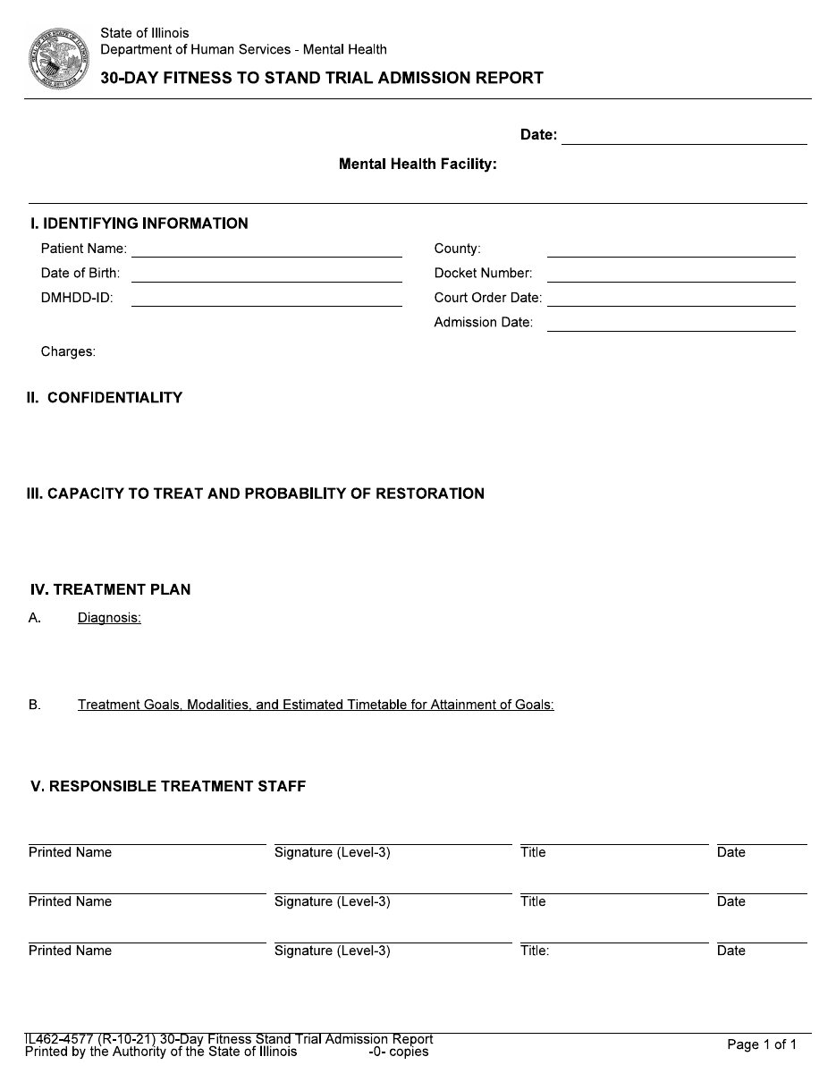

30-Day Outpatient Treatment Narrative & Progress Report | Template

[ENTER FACILITY NAME]
[ENTER FACILITY ADDRESS]
[ENTER FACILITY CITY, STATE, ZIP]
[ENTER DATE]
The Honorable [ENTER JUDGE NAME]
[ENTER COURT NAME]
[ENTER COURT ADDRESS]
[ENTER COURT CITY, STATE, ZIP]
RE: [ENTER DEFENDANT NAME]
Case #: [ENTER CASE NUMBER]
Dear Judge [ENTER JUDGE LAST NAME]:
Pursuant to Your Honor’s Order dated [ENTER COURT ORDER DATE], an outpatient evaluation was performed on the above-stated defendant. It is our opinion that [ENTER Mr./Ms./Mx.] [ENTER DEFENDANT LAST NAME] is [ENTER OPINION FROM LIST BELOW]. The details of the fitness restoration plan are enclosed.
Use one of the following opinion statements:
- “in Need of Mental Health Services on an Outpatient Basis”
- “in Need of Mental Health Services on an Inpatient Basis”
- “Unlikely to Attain Fitness to Stand Trial within the Statutory Period”
- “Currently Fit to Stand Trial—No Further Treatment Required.”

If you have any questions, please contact my office at [ENTER PHONE].
Sincerely,
[ENTER FORENSIC EVALUATOR NAME], [ENTER CREDENTIALS]
[ENTER TITLE]
cc:
[ENTER DEFENSE ATTORNEY NAME] — [ENTER DEFENSE ATTORNEY ORG]
[ENTER STATE’S ATTORNEY OFFICE NAME]
[ENTER COMMUNITY AGENCY CONTACT NAME] — [ENTER COMMUNITY AGENCY NAME]
[ENTER IDHS DEPUTY DIRECTOR NAME] — DBHR Bureau of Forensic & Justice Services

30-Day Fitness to Stand Trial Progress Report
[ENTER DATE]

IDENTIFYING INFORMATION
Patient Name: [ENTER DEFENDANT NAME]
Date of Birth: [ENTER DATE OF BIRTH]
Docket Number: [ENTER CASE NUMBER]
County: [ENTER COUNTY]
Court Order Date: [ENTER COURT ORDER DATE]
Date of Evaluation: [ENTER EVALUATION DATE]
Charges: [ENTER CHARGES]

STATEMENT OF CONFIDENTIALITY
This evaluation was conducted pursuant to court order under 725 ILCS 5/104. The defendant was informed at the outset of the evaluation that the information shared would not be confidential in the usual sense, that a report would be prepared and filed with the court and provided to counsel and IDHS, and that the defendant could decline to participate but a report would still be submitted to the court. The defendant indicated [ENTER understanding, partial understanding, or lack of understanding] of these limits.

CAPACITY TO TREAT AND PROBABILITY OF RESTORATION
[ENTER NARRATIVE]
Narrative should include:
- Supervisor’s clinical judgment on restorability
- An explicit opinion on whether there is a substantial probability that the defendant will attain fitness within the statutory period (one year for felony; sentence length for misdemeanor)
- Recommended setting (outpatient, inpatient, or unable to be restored).

STATEMENT OF OPINION
[ENTER Mr., Ms., or Mx.] [ENTER DEFENDANT LAST NAME] was ordered by [ENTER COUNTY] County Court to report for an outpatient evaluation. It is our opinion that [ENTER Mr., Ms., or Mx.] [ENTER DEFENDANT LAST NAME]:
[STATE whether the individual is subject to involuntary admission]
[STATE whether the individual is in need of inpatient, outpatient or no mental health services.]
[STATE whether the individual is fit to stand not trial. Opinions include]
- Individual is fit to stand trail. No treatment plan is filed and the supporting clinical findings are documented in Section III above.
- Individual is unfit to stand trial but likely to attain fitness within the statutory period. Treatment plans is included in section V.
- Individual is unfit but unlikely to attain fitness within the statutory period due. [PROVIDE REASONS]. The court’s guidance is requested as to next steps.]
Per 725 ILCS 5/104-17(e), if the report indicates a substantial probability that the defendant will attain fitness within the statutory time period, a treatment plan must be filed (Section V below). If the agency determines outpatient capacity is not available, contact the Forensic Outpatient Manager before filing to coordinate higher level of care.

TREATMENT PLAN
File this section only if Section IV indicates the defendant is in need of mental health services on an outpatient basis and there is a substantial probability of restoration. Per 725 ILCS 5/104-17(e), the treatment plan must include diagnoses; treatment goals, modalities, and an estimated timetable; and the person in charge of supervising treatment.
- Diagnoses
Primary: [ENTER PRIMARY DIAGNOSIS]
Secondary: [ENTER SECONDARY DIAGNOSIS, if applicable]
Tertiary: [ENTER TERTIARY DIAGNOSIS, if applicable]
- Treatment Goals
Treatment goals address the three core areas of fitness restoration. Tailor each goal to the defendant’s specific deficits identified in the evaluation.
- Factual understanding of the court process.
[ENTER GOAL DETAIL: e.g., understanding the roles of the prosecutor, defense, judge, and jury; understanding the charges and possible penalties.]
- Rational decision-making related to legal options.
[ENTER GOAL DETAIL: e.g., understanding plea options, weighing evidence, considering consequences.]
- Capacity to assist counsel in defense.
[ENTER GOAL DETAIL: e.g., understanding the attorney’s role, how to communicate relevant information, how to participate in trial.]
- Treatment Modalities
[MODALITIES: List those selected for this defendant.]
- Provider, Location, and Supervision
Treatment Agency: [COMMUNITY AGENCY NAME]
Location: [AGENCY ADDRESS]
Treatment Supervisor: [SUPERVISOR NAME, CREDENTIALS]
Supervisor Contact: [SUPERVISOR PHONE/EMAIL]
Treatment Provider: [PROVIDER NAME, CREDENTIALS]
Provider Contact: [PROVIDER PHONE/EMAIL]
Session Frequency: Weekly at minimum, more often as clinically indicated.
- Estimated Timetable for Attainment of Goals
[TIMETABLE: Typical range is 3 to 9 months; document specifics for this defendant.]
- Medications
Document any current psychiatric medications, prescriber, and the recommendation regarding medication compliance. The 90-day report must include the prescriber’s information on type, dosage, and effect on the defendant’s appearance, actions, and demeanor (per 725 ILCS 5/104-17).
[PROVIDE NARRATIVE: Current medications and compliance recommendation.]
- Additional Services and Recommendations
[PROVIDE NARRATIVE: Additional services such as ongoing individual counseling, psychiatric medication management, substance use treatment, vocational support, or other services as indicated.]
- Plan Review
This treatment plan will be reassessed at 90 days, or sooner if clinically indicated, by [COMMUNITY AGENCY NAME]. The 90-day progress report will be filed with the court at least seven days before the scheduled status hearing.
[Mr./Ms./Mx.] [DEFENDANT LAST NAME] indicated [PRONOUN] would comply with the treatment plan as recommended. If [PRONOUN] fails to participate as recommended, [COMMUNITY AGENCY NAME] will notify the Court, the State, and defense counsel, and consultation with the Forensic Outpatient Manager will occur regarding whether inpatient services or another disposition is warranted.

RESPONSIBLE TREATMENT STAFF

[ENTER FORENSIC EVALUATOR NAME], [ENTER CREDENTIALS]
[ENTER TITLE]
[ENTER DATE]

[ENTER TREATMENT SUPERVISOR NAME], [ENTER CREDENTIALS]
[ENTER TITLE]
[ENTER DATE]

90-Day Fitness to Stand Trial Progress Report | Illustrative Example
Approved version lives in the IDHS document library on the internal intranet and are accessible only to authorized
clinical staff
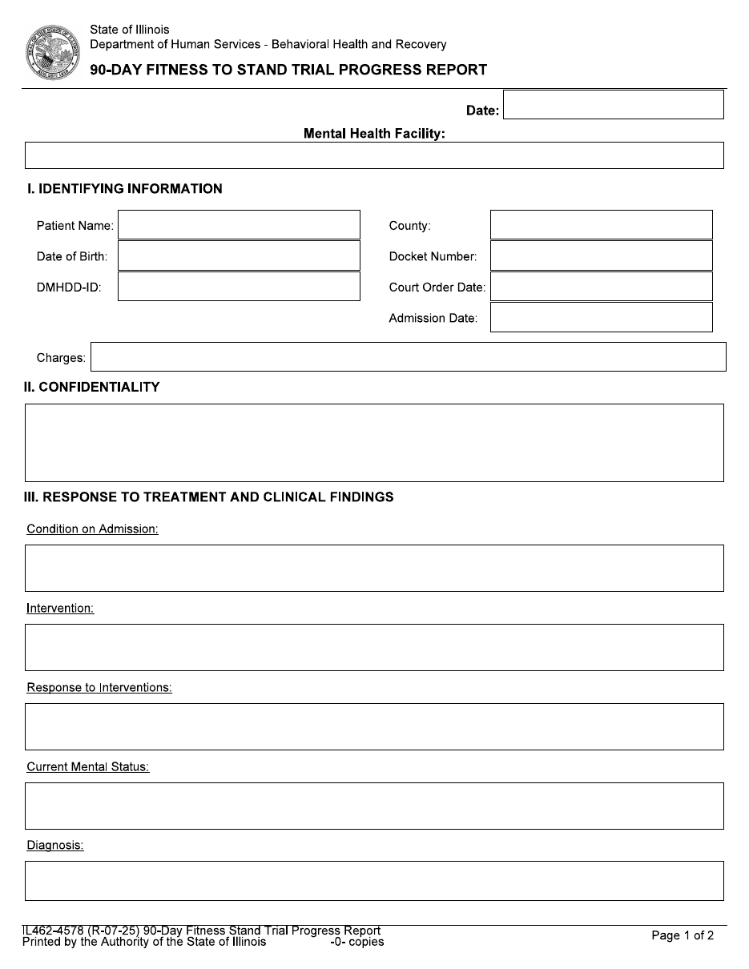

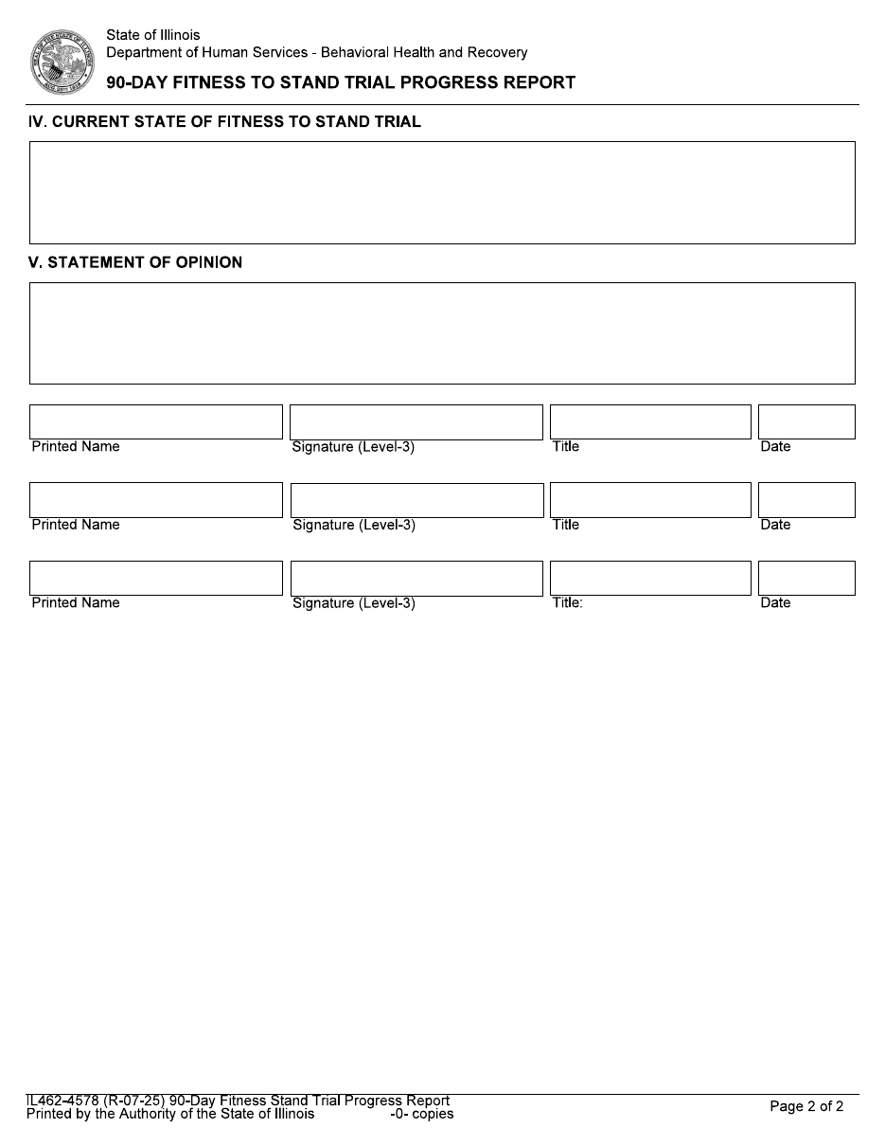

90-Day Outpatient Treatment Narrative & Progress Report | Template

[ENTER FACILITY NAME]
[ENTER FACILITY ADDRESS]
[ENTER FACILITY CITY, STATE, ZIP]
[ENTER DATE]
The Honorable [ENTER JUDGE NAME]
[ENTER COURT NAME]
[ENTER COURT ADDRESS]
[ENTER COURT CITY, STATE, ZIP]
RE:
Defendant: [ENTER DEFENDANT NAME]
Case Number: [ENTER CASE NUMBER]
Dear Judge [ENTER JUDGE LAST NAME]:
Pursuant to Your Honor’s Order dated [ENTER COURT ORDER DATE], we submit this 90-day progress report on the above-stated defendant. [ENTER Mr., Ms. Or Mx.] [ENTER DEFENDANT LAST NAME] has been receiving outpatient fitness restoration services at [ENTER COMMUNITY AGENCY NAME] since [ENTER START DATE]. It is our opinion that [ENTER Mr., Ms. or Mx.] [ENTER DEFENDANT LAST NAME] [ENTER OPINION].
Use one of the following opinion statements:
- “has attained fitness to stand trial”
- “is making substantial progress toward attaining fitness within the statutory period”
- “is making limited progress toward attaining fitness”
- “is unlikely to attain fitness within the statutory period; an aftercare plan is included with this report.”
If you have any questions, please contact my office at [ENTER PHONE].
Sincerely,
[ENTER EVALUATOR NAME], [ENTER CREDENTIALS]
[ENTER TITLE]
cc: [ENTER DEFENSE ATTORNEY NAME] — [ENTER DEFENSE ATTORNEY ORG]
[ENTER STATE’S ATTORNEY OFFICE NAME]
[ENTER COMMUNITY AGENCY CONTACT NAME]

90-Day Outpatient Treatment Progress Report
[ENTER DATE]

IDENTIFYING INFORMATION
Patient Name: [ENTER DEFENDANT NAME]
Date of Birth: [ENTER DATE OF BIRTH]
Case Number: [ENTER CASE NUMBER]
County Court: [ENTER COUNTY]
Court Order Date: [ENTER COURT ORDER DATE]
Date of Initial Report: [ENTER INITIAL 30-DAY REPORT DATE]
Date of Last Report: [ENTER LAST 90-DAY REPORT DATE, if applicable]
Date of This Report: [ENTER REPORT DATE]
Charges: [ENTER CHARGES]

STATEMENT OF CONFIDENTIALITY
This report is filed pursuant to court order under 725 ILCS 5/104. The defendant remains aware that information shared during outpatient treatment is not confidential in the usual sense and is reported to the court, counsel, and IDHS.

RESPONSE TO TREATMENT AND CLINICAL FINDINGS
Per 725 ILCS 5/104-20, this section must include the supervisor’s clinical findings and the facts on which they are based, and—if the defendant is receiving medication—information from the prescribing physician indicating the type, dosage, and effect on the defendant’s appearance, actions, and demeanor.
- Attendance and Engagement
[PROVIDE NARRATIVE: Number of sessions scheduled and attended; cancellations and no-shows; engagement quality; any escalation steps taken under the non-engagement protocol.]
- Response to Treatment
[PROVIDE NARRATIVE: Response to didactic content, role-play, case vignettes, and other modalities; areas of progress and areas of continued difficulty.]
- Medications
[PROVIDE NARRATIVE: Current psychiatric medications, prescriber, dosage, compliance, and the prescriber’s observations on effect on appearance, actions, and demeanor.]
- Current Mental Status
[PROVIDE NARRATIVE: Mental status examination findings: appearance, behavior, speech, mood, affect, thought process, thought content, perception, cognition, insight, judgment.]

PROGRESS TOWARD RESTORATION OF FITNESS
NOTE: Address each of the three core areas. Document specific evidence of progress or continued deficit—not just summary judgments.
- Factual Understanding of the Court Process
[PROVIDE NARRATIVE including the defendant’s current understanding of charges, possible penalties, roles of court personnel, courtroom procedure.]
- B. Rational Decision-Making Related to Legal Options
[PROVIDE NARRATIVE including the defendant’s ability to weigh evidence, consider plea options, and evaluate consequences in case-relevant scenarios.]
- Capacity to Assist Counsel
[PROVIDE NARRATIVE including the defendant’s ability to communicate relevant information to counsel, follow proceedings, and collaborate on defense in a rational manner.]

CURRENT STATE OF FITNESS TO STAND TRIAL
[PROVIDE NARRATIVE including an overall summary of current fitness status, drawing on Sections III and IV. State the basis for the opinion that follows.]

STATEMENT OF OPINION
It is our opinion that [Mr./Ms./Mx.] [DEFENDANT LAST NAME]:
Use one of the following opinion statements:
- Has attained fitness to stand trial. The Court is hereby notified per the immediate-notification requirement under 725 ILCS 5/104-20.
- Is making substantial progress under treatment toward attaining fitness within the statutory time period. Continued outpatient treatment is recommended.
- Is making limited progress under treatment. Continued outpatient treatment is recommended with [SPECIFY ANY MODIFICATIONS].
- Is unlikely to attain fitness within the statutory time period. An aftercare plan is provided in Section VIII below. The Court’s guidance is requested.

CONTINUED TREATMENT PLAN
Required when treatment is to continue. Document modifications to the treatment plan filed at 30 days, including any changes to goals, modalities, frequency, supervisor, or medications. If no modifications, state that the plan filed at 30 days remains in effect and is reattached or available on request.
[NARRATIVE: Continued treatment plan or reference to the 30-day plan still in effect.]

AFTERCARE PLAN (only if Section VI indicates unlikely to attain fitness)
An aftercare plan is required only when the supervisor’s opinion is that the defendant is unlikely to attain fitness within the statutory time period. Address recommended next steps: civil commitment evaluation, continuation of mental health services, community linkage, and any monitoring or follow-up arrangements.
[PROVIDE NARRATIVE describing the aftercare plan, if applicable.]

RESPONSIBLE TREATMENT STAFF

[ENTER DATE]
[ENTER EVALUATOR NAME], [ENTER CREDENTIALS]
[ENTER TITLE]

[ENTER DATE]
[ENTER TREATMENT SUPERVISOR NAME], [ENTER CREDENTIALS]
[ENTER TITLE]

Statewide Immediate Transport Letter & Order | Template
[ENTER DATE]
[ENTER JUDGE NAME]
[ENTER COUNTY COURT]
[ENTER COURT ADDRESS]
[ENTER CITY, STATE, ZIP]

RE: [ENTER DEFENDANT NAME]
[ENTER CASE NUMBER]

Dear [ENTER JUDGE NAME]:

Please see attached report per 725 ILCS 5/104-18(a)(2) which finds the defendant in the above captioned case fit to stand trial. Pursuant to Public Act 100-27, 725 ILCS 5/104-18(c) and 104-20(e)] the defendant is to be immediately returned to the county jail. For your convenience attached is a draft court order for immediate transport of the defendant to the custody of the county jail. We would appreciate prompt receipt of the order to the contact below for transport.

Respectfully,

[ENTER SENDER NAME]
[ENTER SENDER TITLE]
[ENTER FACILITY NAME]

Phone: [ENTER SENDER PHONE]
Fax: [ENTER SENDER FAX]
Email: [ENTER SENDER EMAIL]

COUNTY OF [ENTER COUNTY]
IN THE CIRCUIT COURT OF THE [ENTER CIRCUIT] JUDICIAL CIRCUIT

PEOPLE OF THE STATE OF ILLINOIS
vs.
[DEFENDANT NAME]
Case No.: [CASE NUMBER]

IMMEDIATE TRANSPORT ORDER
This cause coming before the Honorable [ENTER JUDGE NAME], the Court having received, pursuant to 725 ILCS 5/104-18(a)(2), a written progress report in which the supervisor of the defendant’s treatment states that he or she believes that the defendant has attained fitness;
IT IS NOW HEREBY ORDERED THAT:
- Pursuant to 725 ILCS 5/104-20(e), the sheriff is directed to immediately return the defendant to the custody of the [ENTER COUNTY] County Jail, where the defendant shall remain during further proceedings in this matter, including a fitness hearing if ordered by the Court, or until further order of the Court.
- Defendant is to be released from the jurisdiction of the Illinois Department of Human Services [ENTER IDHS FACILITY NAME] Mental Health Center, and is remanded to the [ENTER COUNTY] County Jail or, if the Court so orders, released from custody.
- A copy of this Order shall be delivered to the Illinois Department of Human Services, via email or fax. A copy of this Order shall be delivered to the Sheriff of [ENTER COUNTY] County.
Date: [ENTER DATE]
Entered: [ENTER JUDGE]

To coordinate pick up please notify:
[ENTER COORDINATION CONTACT NAME], [ENTER PHONE] [ENTER EXTENSION]
or
[ENTER BACKUP CONTACT NAME], [ENTER PHONE] [ENTER EXTENSION]

Not Guilty by Reason of Insanity—A Plain Language Guide
A Guide for Individuals found Not Guilty by Reason of Insanity (NGRI)
Law: 730 ILCS 5/5-2-4

About This Guide
This guide explains the NGRI process in plain language. It helps you understand what happens after an NGRI finding, the types of treatment the court may order, and your rights.

What does NGRI mean?
Not Guilty by Reason of Insanity (NGRI) means the court found that because of serious mental illness or intellectual disability at the time of the offense, you were not legally responsible for your actions.
This is not a criminal sentence. Instead, the court orders an evaluation by the Illinois Department of Human Services (IDHS) to decide what supervision or treatment, if any, is needed. The goal of supervision and treatment it to make sure you and others are safe.

What Can the Court Decide?
After the evaluation, the court holds a hearing (a commitment hearing) to decide what happens next. The court then chooses one of three paths.
- Absolute Discharge: You do not need mental health treatment, skills-building services or court supervision. Your case ends.
- Conditional Release: You do not need inpatient treatment, but you still need mental health or skills-building services. You receive treatment in the community and must follow the rules set by the court.
- Secure Inpatient Treatment: You receive treatment or skills-building services in a secure hospital. As you recover, the treatment team may recommend you move to a setting with less security.

What Usually Happens?
Everyone’s recovery is different, but most NGRI cases follow a similar path:
- The court finds you NGRI.
- Illinois Department of Human Services (IDHS) completes an evaluation.
- The court decides what level of care you need.
- You receive treatment.
- Your treatment and progress are reviewed over time.
- If appropriate, you may move to a setting with less security, such as conditional release.
- When you no longer need treatment or skills-building services, or you reach your legal time limit for treatment, the court may order your discharge.
Every case is different. If your condition changes, the court may also decide you need a higher level of care.

Can I Ask the Court to Review My Case?
In most cases, your treatment team tells the court if they think you no longer need inpatient care or no longer need mental
health or skills-building services.
You also have the right to ask the court to review your case. You, a family member, or another person on your behalf may file a petition asking the court to:
- Review your treatment plan
- Grant conditional release
- Grant a discharge

What Happens After I File a Petition?
After the court receives your petition:
- The court schedules a hearing within 120 days.
- If you cannot afford an attorney, they court appoints one for you.
- You, the State, or the court may request an independent evaluation by a psychiatrist or psychologist who does not
work for IDHS.
At the hearing, the court decides whether you meet the legal requirements. If you filed the petition, you must show that you meet the legal standard.

What Will the Court Look At?
When the court reviews your case, it may look at things like:
Your Recovery
- How your mental illness or skills-building progress is doing now
- What medicine you take
- Any side effects from your medicine
- How your health might change if you stopped taking your medicine
Your Understanding
- Whether you understand the harm your past actions caused
- Whether you understand that similar actions would be wrong
Your History & Support
- Any past or possible drug or alcohol use
- Your past criminal record
- Any special medical needs you have
- Whether your family will be involved after release, and if they are able and willing
Safety
- Whether you might be a danger to yourself or others
- Anything else the court finds important
The court uses a legal standard called clear and convincing evidence to make its decision. See law 730 ILCS 5/5-2-4(g).

How Long Can Court Oversight Last?
Oversight cannot extend past the Thiem Date. In most cases, the Thiem Date is the longest possible sentence you could have received for the original offense.
In many NGRI cases, people are granted absolute discharge before the Thiem Date. Absolute Discharge ends IDHS and court oversight. Conditional Release keeps some treatment and oversight that can later lead to Absolute Discharge.
When the Thiem Date is reached, criminal court oversight must end. In some cases, treatment may continue under a different law. This is called civil commitment.

What Happens Before Release?
Before ordering Conditional Release or Absolute Discharge, the court directs the facility to prepare a discharge plan.
The plan may include:
- A place to live
- Mental health treatment or skills-building services
- Medication
- Community support
- Training to safely manage your medicine, if appropriate
See law 730 ILCS 5/5-2-4, subsections (d) through (h).

Need Help?
You have the right to:
- Have an attorney
- Ask questions about your case
- Ask the court to review your case by filing a petition
Free legal help is available through the Legal Advocacy Services.

Central Intake (toll free): 1 (866) 274-8023

This plain-language overview is for orientation only. It is not legal or clinical advice and is not a policy document. Laws and procedures can change. For your own situation, talk to your attorney or IDHS staff. Law: NGRI 730 ILCS 5/5-2-4.

Petitioning the Court on Your Own to Review Your Case
A Guide to Requesting a Review of Your Treatment Plan, Conditional Release, or Discharge for individuals found Not Guilty by Reason of Insanity (NGRI).
Law: 730 ILCS 5/5-2-4

About This Guide
This guide explains the process in plain language to help you understand your options and what to expect. While this guide is written to be easier to understand, any forms or legal documents must be completed and filed using the required legal language and format. This overview is for orientation only. It is not legal or clinical advice and is not a policy document. Laws and procedures can change. For your own situation, talk to your attorney or IDHS staff.

Your Right to Ask the Court
You have the right to ask the court to review your case. The court that found you NGRI is the court you file with. You can ask the court to:
- Review your treatment plan and see if changes should be made to your current care.
- Grant conditional release so you can leave inpatient care and keep getting treatment in the community.
- Grant a discharge if you no longer need mental health or skills-building services
You can file the petition, or a family member or another person can also file it for you.

What’s Included in This Packet
This packet has:
- A short guide that explains the process
- A list of offices that give free legal help
- The petition (the form you send to the court)
- A cover letter to the judge
- A cover letter to the clerk

What Happens After You File
After the court receives your petition:
- The court will set a hearing date within 120 days.
- If you cannot afford a lawyer, the court will appoint one for you.
- You, or the court, may ask for an independent exam by a doctor who does not work for IDHS.

If the court does not schedule a hearing within 120 days, you can contact the Guardianship and Advocacy Commission. A list of offices with free legal help is included below.

Discharge or Conditional Release: What Is the Difference?
Discharge: You no longer need mental health treatment or skills-building services. The court must agree that the treatment is no longer necessary.
Conditional Release: You no longer need inpatient care, but you still need mental health treatment. If the court approves your request, you can get treatment in the community as long as you follow the court’s rules.

Who Can Help?
Every facility has at least one Petition Assistant. The Petition Assistant will:
- Give you your case number, the judge’s name, and the court’s address.
- Show you where to write your name and where to sign.
- Help you fill out the forms if you ask. They will only write what you tell them to write.
- Tell your treatment team that you are filing.
The Petition Assistant works for IDHS. They are there to help you send your forms to the court. They cannot make the court hold a hearing.

What Will the Court Look At?
When the court reviews your case, it may look at things like:
- Whether you understand the harm your past actions caused.
- Whether you understand that similar actions would be wrong.
- How your mental illness or skills-building needs are doing now.
- What medicine you take for your mental illness.
- Any bad side effects from your medicine.
- How fast your health would get worse if you stopped taking your medicine.
- Any past or possible drug or alcohol use.
- Your past criminal record.
- Any special medical needs you have.
- Whether your family will be involved after release, and if they are able and willing.
- Whether you might be a danger to yourself or others.
- Anything else the court finds important.

Free Legal Help
The Legal Advocacy Service (LAS) gives free legal advice to adults and children with disabilities. They help with things like leaving the hospital, getting good care, refusing care you do not want, and keeping your records private.
Call central intake (toll free): 1 (866) 274-8023
Outside Illinois: 1 (708) 338-7500
Find your regional office below by your county.
Regional Office | Counties Served
East Central  2125 South 1st St  Champaign, IL 61820  Phone: (217) 278-5577  Fax: (217) 278-5588 | Champaign, Christian, Clark, Coles, Cumberland, DeWitt, Douglas, Edgar, Ford, Iroquois, Kankakee, Livingston, Logan, Macon, McLean, Moultrie, Piatt, Shelby, Vermilion
Egyptian  #7 Cottage Drive  Anna, IL 62906  Phone: (618) 833-4897  Fax: (618) 833-5219 | Alexander, Clay, Crawford, Edwards, Effingham, Fayette, Franklin, Gallatin, Hamilton, Hardin, Jackson, Jasper, Jefferson, Johnson, Lawrence, Marion, Massac, Perry, Pope, Pulaski, Richland, Saline, Union, Wabash, Washington, Wayne, White, Williamson
Metro East  115 N. Buchanan Street, 2nd Floor  Edwardsville, IL 62025  Phone:(618) 659-7025  Fax: (217) 557-8470 | Bond, Calhoun, Clinton, Greene, Jersey, Macoupin, Madison, Monroe, Montgomery, Morgan, Pike, Randolph, Scott, St. Clair
North Suburban  9511 Harrison Ave, W-335  Des Plaines, IL 60016  Phone: (847) 294-4264  Fax: (847) 294-4263 | DuPage, Kane, Kendall, Lake, McHenry, Northwest Cook County, and Chicago north of Foster Ave (5200 N).
Peoria  401 Main Street, Suite 620  Peoria, IL. 61602  Phone: (309) 671-3030  Fax: (309) 671-3060 | Adams, Brown, Bureau, Cass, Fulton, Hancock, Henderson, Henry, Knox, LaSalle, Marshall, Mason, McDonough, Menard, Mercer, Peoria, Putnam, Rock Island, Sangamon, Schuyler, Scott, Stark, Tazewell, Warren, Woodford
Rockford  4302 North Main Street  Rockford, IL 61103  Phone: (815) 987-7657  Fax: (815) 987-7227 | Boone, Carroll, DeKalb, Jo Daviess, Lee, Ogle, Stephenson, Whiteside, Winnebago
West Suburban  P.O. Box 7009  Hines, IL 60141  Phone: (708) 338-7500  Fax: (708) 338-7505 | Cook County South of 5200 North, Will, Grundy

Steps to Prepare the Petition and Letters
The next pages are the forms you send to the court. The wording must stay as written so the court accepts them. [BRACKETS LIKE THIS] show where you need to fill in information.
Step 1. Fill out the Petition
- Print your name where it says, “your name.”
- Write your case number and the judge’s name at the top.
- Sign the petition.
- At the bottom, write your name, address, phone, and the date.
Step 2. Fill Out the Cover Letter to the Judge
- Print your name and address at the top.
- Write today’s date.
- Write the judge’s name.
- Sign it.
Step 3. Fill Out the Cover Letter to the Clerk
- Print your name and address at the top.
- Write the date.
- Write the clerk’s name.
- Sign it.
Step 4. Make Two Copies and Turn Them In
- Make two copies of the petition, the letter to the judge, and the letter to the clerk.
- Bring them to the Petition Assistant.
- Petition Assistant will send the letters and petition to the judge and clerk.
- If you want to mail them yourself, tell the assistant. They will give you envelopes and postage.

COUNTY OF [ENTER COUNTY]
IN THE CIRCUIT COURT OF THE [ENTER CIRCUIT] JUDICIAL CIRCUIT

PEOPLE OF THE STATE OF ILLINOIS
vs.
[ENTER DEFENDANT NAME]
Case No.: [ENTER CASE NUMBER

PETITION FOR DISCHARGE OR CONDITIONAL RELEASE
Pursuant to 730 ILCS 5/5-2-4(e) and the Illinois Supreme Court’s holding in Radazewski v. Cawley, 159 Ill.2d 372 (1994), the Court shall set this matter for a hearing to be held within 120 days of receipt of this Petition.
Petitioner [ENTER PETITIONER NAME], hereby petitions this Court, pursuant to 730 ILCS 5/5-2-4(e) to review his/her Treatment Plan or discharge or conditionally release him/her from the custody of the Illinois Department of Human Services (IDHS), and,
IN SUPPORT THEREOF, states the following:
- Petitioner was found not guilty by reason of insanity and was committed to the custody of IDHS under 730 ILCS 5/5-2-4.
- Petitioner is presently confined at [ENTER FACILITY NAME] Mental Health Center.
- Petitioner is [ENTER STATEMENT FROM OPTIONS BELOW].
- For conditional release: “not subject to involuntary admission and no longer needs mental health services on an inpatient basis”
- For discharge: “not subject to involuntary admission and no longer needs mental health services on an inpatient or outpatient basis”
- Petitioner is indigent.
- Petitioner has not filed a Petition under 730 ILCS 5/5-2-4(e) within the past 120 days from the date of this Petition.
WHEREFORE, in relief, Petitioner respectfully requests this Court to:
- Appoint counsel to represent Petitioner under 730 ILCS 5/5-2-4(c);
- Order that an impartial psychiatric or psychological examination of Petitioner be conducted where appropriate pursuant to 730 ILCS 5/5-2-4(f), and at the expense of the county;
- Set this matter for hearing within 120 days, under 730 ILCS 5/5-2-4(e) and Radazewski v. Cawley, 159 Ill.2d 372 (1994), to decide whether Petitioner may be [ENTER STATEMENT FROM OPTIONS BELOW]; and
- conditionally released
- unconditionally discharged from IDHS custody
- Notify Petitioner of the hearing date and arrange for him/her to be present at said hearing.

Petitioner’s Signature: [ENTER SIGNATURE]
Print Name: [PRINT NAME]
Date: [ENTER DATE]
Address: [ENTER ADDRESS]
Phone: [ENTER PHONE]
Email: [ENTER EMAIL]

Cover Letter to the Judge
Brought under 730 ILCS 5/5-2-4.
Date: [ENTER DATE]
Name: [ENTER YOUR NAME]
Address: [ENTER YOUR ADDRESS]
City, State, ZIP: [ENTER YOUR CITY, STATE, ZIP]
RE: Docket / Case Number: [ENTER DOCKET NUMBER / CASE NUMBER]

Dear Judge [ENTER JUDGE’S LAST NAME]
Enclosed please find my Petition for [ENTER Treatment Plan Review, Conditional Release OR Discharge] filed under 730 ILCS 5/5-2-4(e). According to the statute and the Illinois Supreme Court’s holding in Radazewski v. Cawley, 159 Ill.2d 372 (1994), the court shall set this matter for a hearing to be held within 120 days of receipt of this Petition.
In addition to setting this matter for hearing, I respectfully ask that you appoint counsel and order an independent psychiatric exam pursuant to 730 ILCS 5/5-2-4(c) and (f) respectively, and at the expense of the county. Thank you very much.

Sincerely,
Petitioner Signature [ENTER SIGNATURE]

cc:
State’s Attorney
Defense Attorney
Mental Health Center

Cover Letter to the Clerk
Brought under 730 ILCS 5/5-2-4.
Date: [ENTER DATE]
Name: [ENTER YOUR NAME]
Address: [ENTER YOUR ADDRESS]
City, State, ZIP: [ENTER YOUR CITY, STATE, ZIP]]
RE: Docket / Case Number: [ENTER DOCKET NUMBER / CASE NUMBER]

Dear Circuit Clerk: [ENTER CLERK’S LAST NAME]
Enclosed please find my Petition for [ENTER Treatment Plan Review, Conditional Release OR Discharge] filed under 730 ILCS 5/5-2-4(e). According to the statute and the Illinois Supreme Court’s holding in Radazewski v. Cawley, 159 Ill.2d 372 (1994), the court shall set this matter for a hearing to be held within 120 days of receipt of this Petition.
Please place this matter on the Judge’s call so a hearing is properly set. Thank you very much.
Sincerely,
Petitioner Signature: [ENTER SIGNATURE]

cc:
State’s Attorney
Defense Attorney
Mental Health Center

The What, Where, When, Why, and How of a Conditional Release | Procedures
For Community Providers

Who:
Clients who are considered eligible for a conditional release from Forensic Treatment are considered to need mental health services but to not be in need of treatment in a hospital setting. After committing a criminal offense, clients are considered “Not Guilty” due to his or her psychiatric illness. By law, an NGRI client was found mentally ill at the time of the offense, where he or she did not appreciate or understand that a crime was being committed.
Clients who have been found NGRI may eventually be able to be granted a Conditional Release by the Court based upon evidence of stability, and evidence of a comprehensive aftercare plan, which addresses all risk factors.
Division of Behavioral Health and Recovery (DBHR) is mandated to monitor and record Court Ordered treatment services provided to NGRI conditionally released patients. Public Act 93-0078 and Public Act 93-0473 require monitoring of reports on the provision of services of both Conditionally Released and Outpatient Treatment orders.

What:
A Conditional Release is granted by the Court, based upon an Aftercare Plan which is developed by the treatment team. This is a very detailed, continuity of care plan detailing the continuing treatment needs of the client and sources for those treatment services.
This client would be expected to adhere to a comprehensive plan that focuses on management of risk factors.
- Treatment modalities being used to address risk factors (e.g., psychotropic medications, counseling services, substance abuse groups).
- Mental health/substance abuse services.
- Supervision/monitoring.
Upon discharge, your agency as the “treatment service provider of record” would be the party responsible for updating these reports and sending these to the Court.
Status Reports/Treatment Plan Updated: These reports must be submitted periodically to the Courts.
This report is generally referred to as a “Status Report” or “Treatment Plan Update.” A 3-month report should provide the Court with a Status Report with clinical recommendations regarding the client’s response to Court Ordered treatment.
Under a Conditional Release order, this client would need to continue living in the Residential Facility until the
date which is set by the Court. A Thiem date is in effect for periods of 5 years or until the maximum period of commitment (Thiem Date).

When:
Legal statutes require that various aspects of Court Ordered treatment are to be addressed on a periodic basis by the service provider. The report is required to be submitted every 90 days for status hearings. Reports are required to be at the Court at least 7 days prior to hearings.
The Thiem date is set by law and it terminates the Criminal Court’s jurisdiction over the client and requires a discharge hearing. The discharge hearing acknowledges that the Criminal Court no longer has jurisdiction over the individual. However, if the individual is recommended for civil commitment, the issue will be referred to the Civil Courts for determination. The terms for Conditional Release NGRI are set by the Courts and are in effect for periods of 5 years or until the maximum period of commitment (Thiem Date). The Court also must be advised when a client reaches their Thiem Date and should receive a Treatment Plan for Aftercare whenever a client is discharged from Court Ordered outpatient treatment.

How:
The NGRI client is mandated by Court to comply with the conditions of the Comprehensive Aftercare Plan. This plan is focused on management of risk factors so that the client successfully reintegrates into living in a less restrictive setting.
If the client does not adhere to his or her Comprehensive Aftercare Plan and is engaging in risky behaviors: this may include taking psychotropic medications, attending treatment and counseling services, and rules of the supervising agency, the client may be found in “contempt of court” and sanctions may be applied to the client. To assist in these issues, please do not hesitate to contact forensic community services administrators.

Why:
The aftercare plan was developed by this client’s treatment team for the purpose of managing risk factors and allowing for services in a setting other than a hospital operated by DHS Division of Behavioral Health and Recovery. When developing a Comprehensive Aftercare Plan, the treatment team will be identifying numerous community resources, which will help manage the client’s risk factors. Clients under a conditional release order must follow the conditions for managing psychiatric, addictions, and other issues upon release. This should ensure that the client remains stable and compliant with evidence-based treatment because it is ordered by the Court.
No changes should occur until there is an official Court Order. If your agency has a better plan or wishes to modify this plan of managing the client’s risk factors, your agency should include these recommendations with the 90-day Status Report.
This report helps the Court remain better able to monitor conditionally released clients and whether they are abiding by the required Court mandates or the “conditions of the client’s release.”
A client who does not wish to adhere to the conditions of a release, risks having the conditional release revoked, and a readmission to a forensic facility.

Where:
A conditional release is granted by the Court where a client was charged. Reports to the Court are sent to the Court that has granted the conditional release. The report should be sent to the Judge, the States Attorney, and the Public Defender or Attorney who is representing the individual. The hospital or referral source should provide this to you.
Copies of these reports should also be sent to Forensic Community Services Administrators.

NGRI Outpatient Treatment Cover Letter & Progress Report | Template

(COMMUNITY AGENCY LETTERHEAD)
[ENTER DATE]
The Honorable [ENTER JUDGE LAST NAME
Judge of the Circuit Court of [ENTER COUNTY]
[ENTER COURT ADDRESS]
RE: [ENTER PATIENT’S NAME]
Case Docket Number: [ENTER CASE DOCKET NUMBER]
Dear Judge [ENTER JUDGE LAST NAME]
Pursuant to Your Honor’s Order dated [ENTER DATE OF COURT ORDER], [ENTER PATIENT’S NAME] continues to receive outpatient treatment at [ENTER AGENCY NAME]. The details of [ENTER PRONOUN] progress in treatment are enclosed.
If you require additional information, please do not hesitate to contact me at [ENTER PHONE NUMBER].
Sincerely,
[ENTER CASE MANAGER NAME]
Cc: Public Defender’s Office
State’s Attorney’s Office
IDHS Forensic Community Services Administrators

Outpatient Treatment Progress Report
(ENTER Client’s name)
(ENTER Docket number)
(ENTER Date)

IDENTIFYING INFORMATION
- Facts that identify patient (e.g., age, race, marital status, crime, date found NGRI, date conditionally released, etc.).

CURRENT MENTAL STATUS
- Results of mental status assessment.
- Assessment of patient’s clinical stability.
- Current risk assessment.
- Diagnoses (i.e., Axis I, II, and III).

PSYCHOTROPIC MEDICATIONS
- Current medications, dosage, and frequency.
- Provisions to ensure that the patient will receive psychotropic medication if recommended.
- Provisions to assure the safety of the patient and others in the event the patient is no longer receiving psychotropic medication.

TREATMENT SERVICES
- Comprehensive plan that focuses on management of risk factors.
- Treatment modalities being used to address risk factors (e.g., psychotropic medications, counseling services, substance abuse groups).
- Mental health/substance abuse services.
- Supervision/monitoring. Living arrangements/shelter.
- Other Supportive Services.

RESPONSE TO TREATMENT
- Patient’s compliance with treatment.
- Response to treatment.
- Significant changes and reasons for those changes (e.g., progress, deterioration).

This Treatment Plan is consistent with Court Order [ENTER COURT ORDER NUMBER], dated [ENTER DATE OF COURT ORDER].

QUALIFIED PROFESSIONALS RESPONSIBLE FOR TREATMENT
(List treatment team members)

30-Day NGRI Inpatient Evaluation | Illustrative Example
Approved version lives in the IDHS document library on the internal intranet and are accessible only to authorized
clinical staff
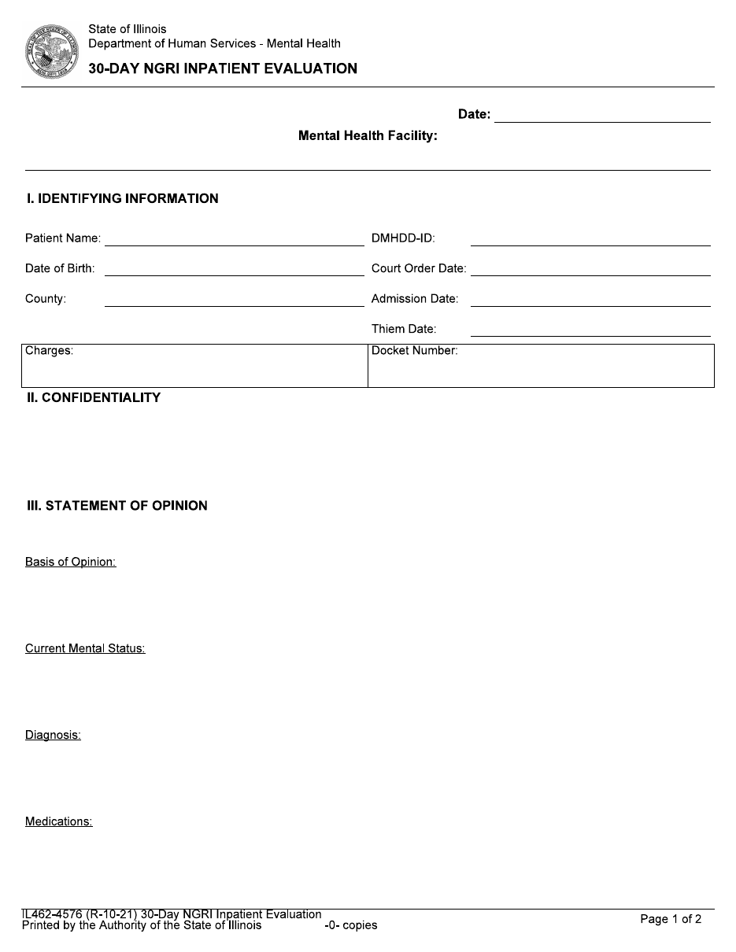

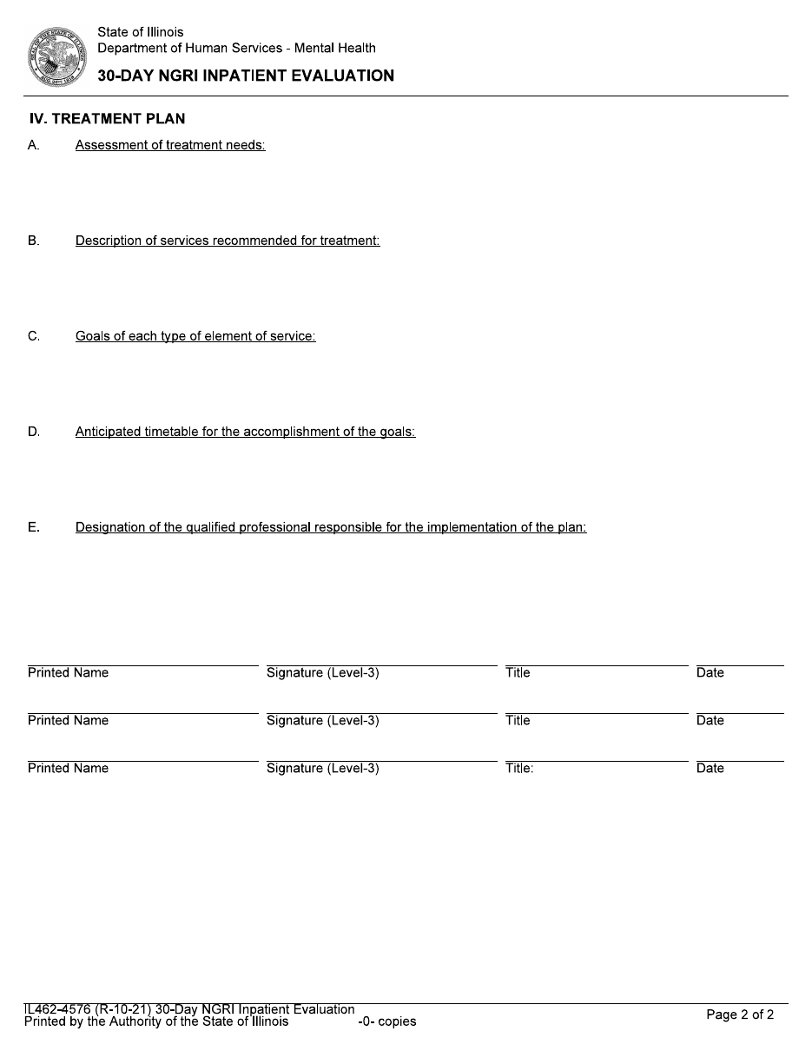

90-Day NGRI Progress and Treatment Plan | Illustrative Example
Approved version lives in the IDHS document library on the internal intranet and are accessible only to authorized
clinical staff
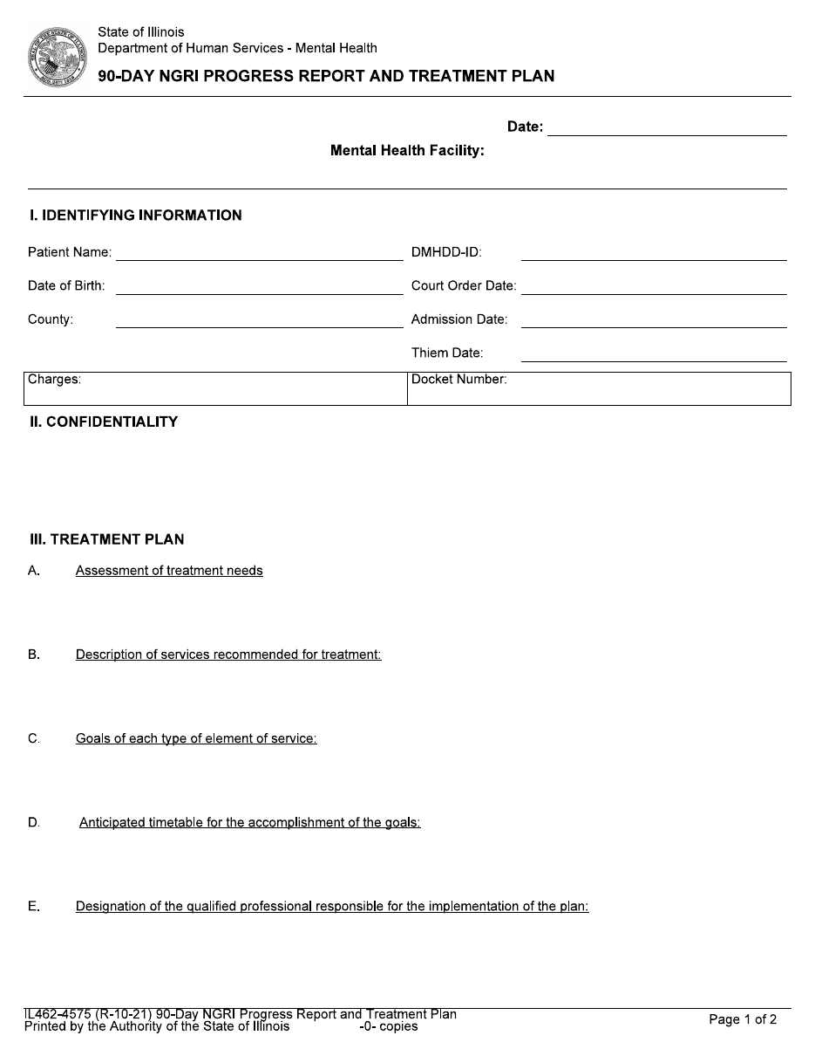
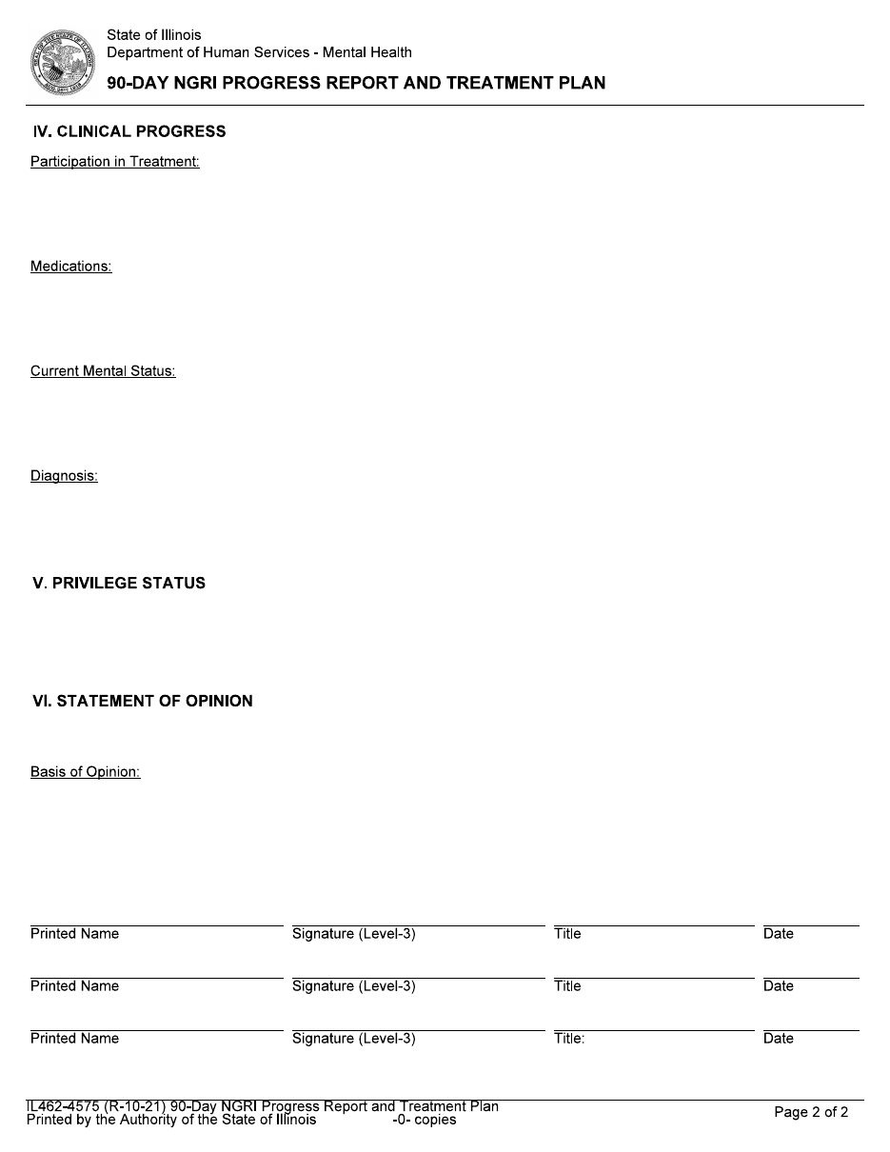

ILLINOIS DEPARTMENT OF HUMAN SERVICES
[ENTER FACILITY NAME] MENTAL HEALTH CENTER
FORENSIC TREATMENT PROGRAM

Recommendation for Conditional Release
Re: [ENTER PATIENT NAME]
Docket#: [ENTER DOCKET NUMBER]
Date: [ENTER DATE]
The Clinical Treatment Team of the Forensic Treatment Program (FTP) at [ENTER FACILITY NAME] Mental Health Center is of the opinion that [ENTER PATIENT’S NAME] has made progress in treatment and has demonstrated clinical and behavioral stability for an extended period of time. He/she is cooperative and compliant with treatment including medications and has demonstrated an appropriate and responsible use of his/her on-ground and off-ground passes. The Treatment Team is recommending that the court authorize the Department of Human Services (DHS) to conditionally release [ENTER PATIENT’S NAME] to [ENTER COMMUNITY AGENCY].

IDENTIFYING INFORMATION
Identifiable facts and reason for admission (name, age, ethnicity, NGRI date of adjudication, crime, Thiem date, etc.)

PERTINENT HISTORY
- Family/Social history
- Educational history
- Psychiatric history
- Significant medical history
- Criminal history
- Substance abuse
- Other pertinent information as needed

ISSUES RELEVANT TO THE NGRI CRIME
- Circumstances of offense
- Psychiatric and medical condition at time of offense

HOSPITAL COURSE
- Psychiatric and medical condition at time of admission
- Treatment(s) and medications provided/prescribed and compliance with each
- Behavior and other incidents
- Assessment of use of court approved privileges including, but not limited to a review of documentation pertaining to any unauthorized absence (UA) threats or attempted elopement
Current Level of Functioning:
- Current presentation of psychiatric/medical symptoms and length of stability
- Motivation for continued treatment
Current Mental Status:
- Results of formal mental status assessment
- Insight to mental illness and its relation to the indexed offense
Psychotropic medications prescribed and level of effectiveness:
- Current medications, doses, and frequency
- Psychiatric symptoms in remission/well managed with medication?
- Medication side effects
- Medication compliance; length of compliance
Diagnoses:
Primary:
Secondary:
Medical:

SECTION 5-2-4 (g) ISSUES
- Whether the individual appreciates the harm caused to others and the community by his or her prior conduct that resulted in the finding of not guilty by reason of insanity
- Whether the person appreciates the criminality of conduct similar to the conduct for which he or she was originally charged in this matter
- The current state of the individual's illness
- What, if any, medications the individual is taking to control his or her mental illness
- What, if any, adverse physical side effects the medication has on the individual
- The length of time it would take for the individual's mental health to deteriorate if the individual stopped taking prescribed medication
- The individual's history or potential for alcohol and drug abuse
- The individual's past criminal history
- Any specialized physical or medical needs of the individual
- Any family participation or involvement expected upon release and what is the willingness and ability of the family to participate or be involved
- The individual's potential to be a danger to himself, herself, or others

RISK ASSESSMENT
- Assessment of imminent dangerousness
- Results of formal assessment
- Static, dynamic, chronic, and acute factors
- Opinion on current and future risk, as well as any conditions that impact such risk

AFTERCARE AND RISK MANAGEMENT PLAN
- Continued treatment and monitoring services needed in the community
- Information of the community agency that has agreed to provide services to individual in the community
- Address responsibilities of the community agency for monitoring and supervising the individual
- Indicate how risk factors in section VI. can be assessed and managed if conditional release is granted; Likelihood the Individual may be expected to be dangerous in the near future, and the conditions under which this may occur.

SUMMARY
Brief summary of findings and rationale for request to conditionally release.

RECOMMENDATIONS:
The Clinical Treatment Team of the Forensic Treatment Program (FTP) at [ENTER FACILITY NAME] Mental Health Center is of the opinion that [ENTER PATIENT’S NAME] has made progress in treatment and has demonstrated clinical and behavioral stability for an extended period of time. He/she is cooperative and compliant with treatment including medications and has demonstrated an appropriate and responsible use of his/her on-ground and off-ground passes. The Treatment Team is recommending that the court authorize the Department of Human Services (DHS) to conditionally release [ENTER PATIENT’S NAME] to [ENTER COMMUNITY AGENCY].
- Treatment recommendations to be provided by community agency
- Identify who will be responsible to submit 90-day progress reports to the court and provide contact information
- Indicate how community agency was instructed to address any form of individual’s noncompliance with conditions of release
- Recommendations for how court should handle potential noncompliance by individual (i.e. return to DHS facility)

DESIGNATED QUALIFIED PROFESSIONALS RESPONSIBLE FOR THE IMPLEMENTATION OF THE PLAN

Psychiatrist: [ENTER NAME AND CREDENTIALS], [SIGN]
Social Worker II: [ENTER NAME AND CREDENTIALS], [SIGN]

